

MULTIMEDIA UNIVERSITY ®

TMA1301 – COMPUTATIONAL METHODS

Group Assignment

Title: Monte Carlo Queuing Simulation

Prepared by:   
Leader: 1142701684 NG CHIN ANN [chinann6213@gmail.com](mailto:chinann6213@gmail.com)

Member: 1142701883 KHOR KIA KIN [0jetpistol0@gmail.com](mailto:0jetpistol0@gmail.com)

Member: 1142701444 TEY MENG KIAT [manjorney@gmail.com](mailto:manjorney@gmail.com)

Date: 22 FEBRUARY 2016

Table of Contents

1. FLOW CHART 1

1.1 SIMPLIFIED VIEW OF EACH SIMULATION 1

1.2 START AND ERROR HANDLING 2

1.3 SERVICE TIME TABLE 3

1.4 INTER-ARRIVAL TIME TABLE 4

1.5 ITEM TABLE 5

1.6 SIMULATION TABLE 6

1.7 COUNTER STATUS 7

1.8 CONCLUSIONS AND END 8

2. OUTPUT 9

2.1 ONE SERVER (OFF PEAK HOURS) 9

2.1.1 TABLE OF CONTENTS 9

2.1.2 SERVICE TIME TABLE 9

2.1.3 INTER-ARRIVAL TIME TABLE 9

2.2.4 ITEM TABLE 10

2.1.5 SIMULATION TABLE 10

2.1.6 COUNTER STATUS 11

2.1.7 EVALUATION OF RESULTS 11

2.1.8 CONCLUSIONS 11

2.2 TWO SERVERS (MODERATE PEAK HOURS) 12

2.2.1 TABLE OF CONTENTS 12

2.2.2 SERVICE TIME TABLE 12

2.2.3 INTER-ARRIVAL TIME TABLE 13

2.2.4 ITEM TABLE 13

2.2.5 SIMULATION TABLE 14

2.2.6 COUNTER STATUS 14

2.2.7 EVALUATION OF RESULTS 15

2.2.8 CONCLUSIONS 15

2.3 THREE SERVERS (HIGH PEAK HOURS) 16

2.3.1 TABLE OF CONTENTS 16

2.3.2 SERVICE TIME TABLE 16

2.3.3 INTER-ARRIVAL TIME TABLE 17

2.3.4 ITEM TABLE 17

2.3.5 SIMULATION TABLE 18

2.3.6 COUNTER STATUS 18

2.3.7 EVALUATION OF RESULTS 19

2.3.8 CONCLUSIONS 19

# 1. FLOW CHART

## 1.1 SIMPLIFIED VIEW OF EACH SIMULATION

C:\Users\Owner\Desktop\TMA1301 Assignment\Flowcharts\00.png

## 1.2 START AND ERROR HANDLING

C:\Users\Owner\Desktop\TMA1301 Assignment\Flowcharts\01.png

## 1.3 SERVICE TIME TABLE

C:\Users\Owner\Desktop\TMA1301 Assignment\Flowcharts\02.png

## 1.4 INTER-ARRIVAL TIME TABLE

C:\Users\Owner\Desktop\TMA1301 Assignment\Flowcharts\03.png

## 1.5 ITEM TABLE

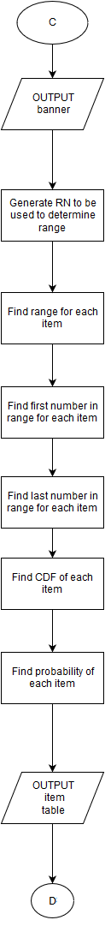

## C:\Users\Owner\Desktop\TMA1301 Assignment\Flowcharts\05.png1.6 SIMULATION TABLE

## 1.7 COUNTER STATUS

C:\Users\Owner\Desktop\TMA1301 Assignment\Flowcharts\06.png

## 1.8 CONCLUSIONS AND END

C:\Users\Owner\Desktop\TMA1301 Assignment\Flowcharts\07.png

# 2. OUTPUT

## 2.1 ONE SERVER (OFF PEAK HOURS)

### 2.1.1 TABLE OF CONTENTS

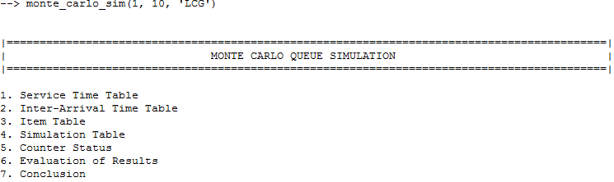

### 2.1.2 SERVICE TIME TABLE

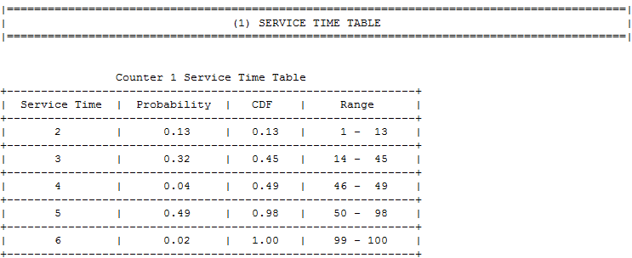

### 2.1.3 INTER-ARRIVAL TIME TABLE

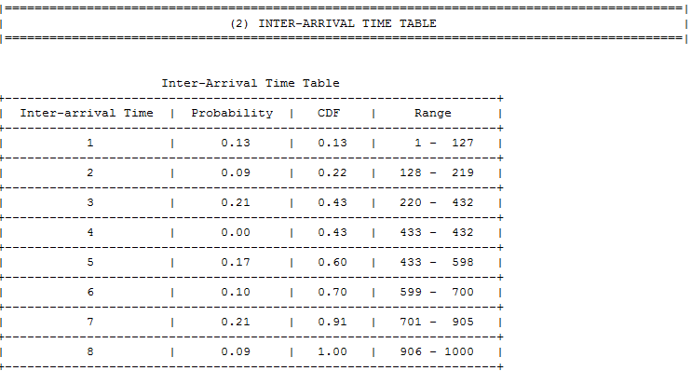

### 2.2.4 ITEM TABLE

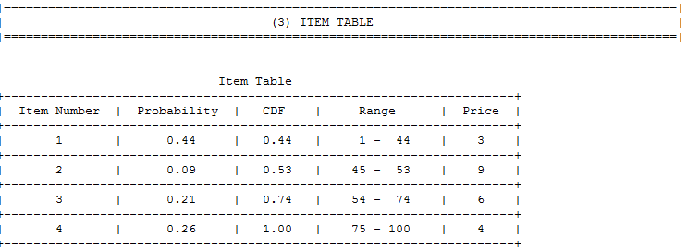

### 2.1.5 SIMULATION TABLE

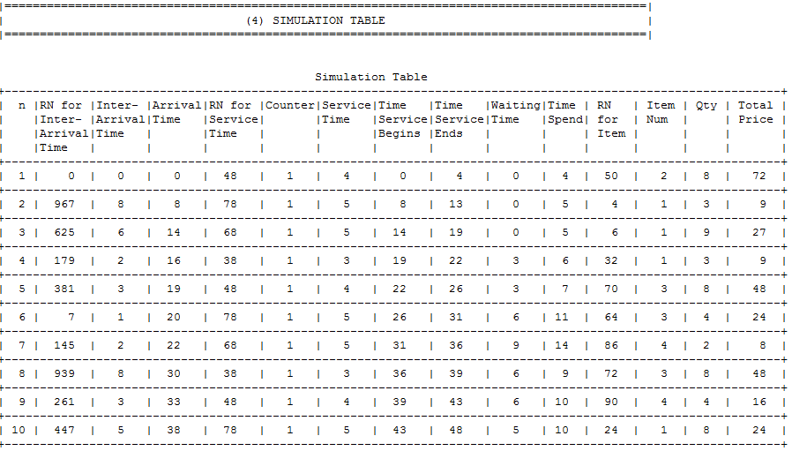

### 2.1.6 COUNTER STATUS

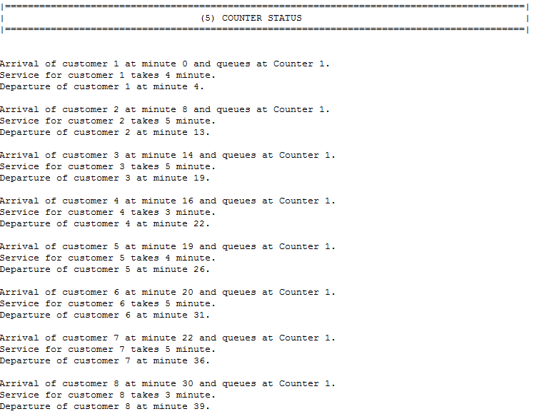

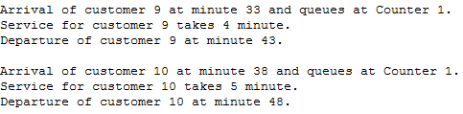

### 2.1.7 EVALUATION OF RESULTS

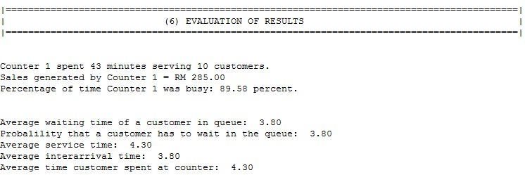

### 2.1.8 CONCLUSIONS

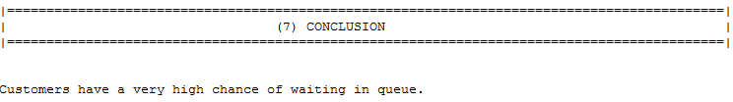

## 2.2 TWO SERVERS (MODERATE PEAK HOURS)

### 2.2.1 TABLE OF CONTENTS

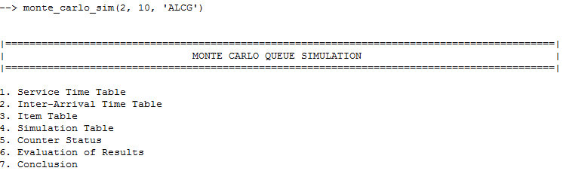

### 2.2.2 SERVICE TIME TABLE

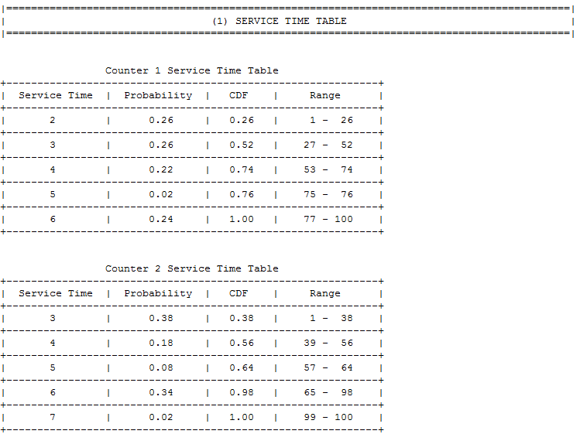

### 2.2.3 INTER-ARRIVAL TIME TABLE

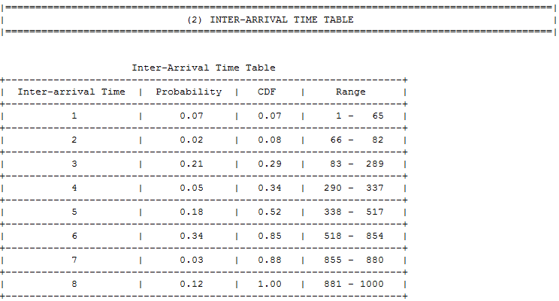

### 2.2.4 ITEM TABLE

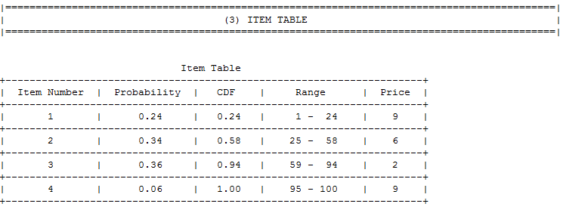

### 2.2.5 SIMULATION TABLE

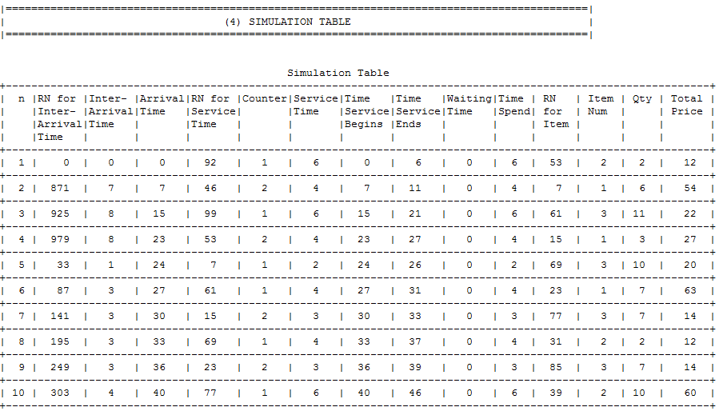

### 2.2.6 COUNTER STATUS

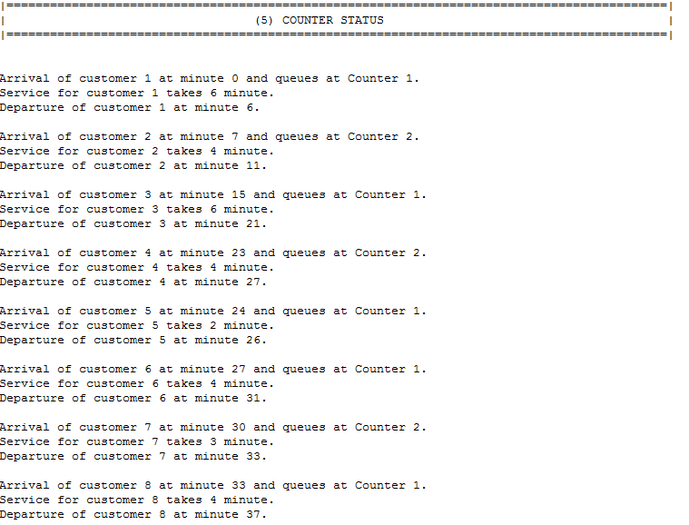

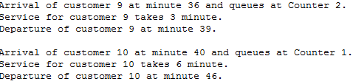

### 2.2.7 EVALUATION OF RESULTS

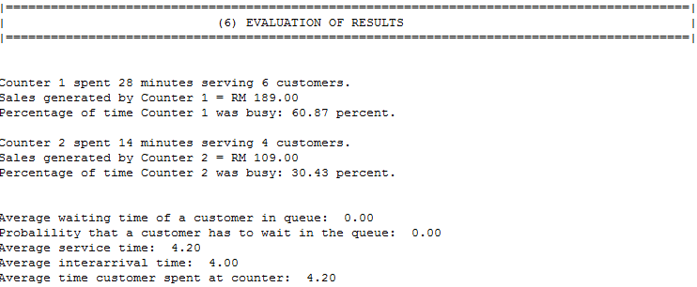

### 2.2.8 CONCLUSIONS

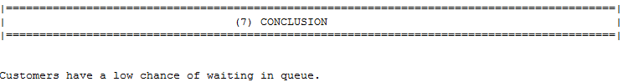

## 2.3 THREE SERVERS (HIGH PEAK HOURS)

### 2.3.1 TABLE OF CONTENTS

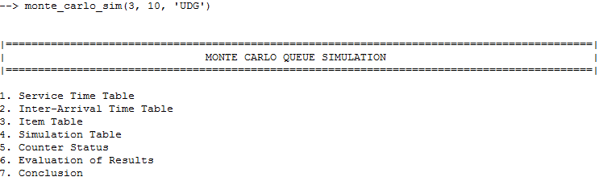

### 2.3.2 SERVICE TIME TABLE

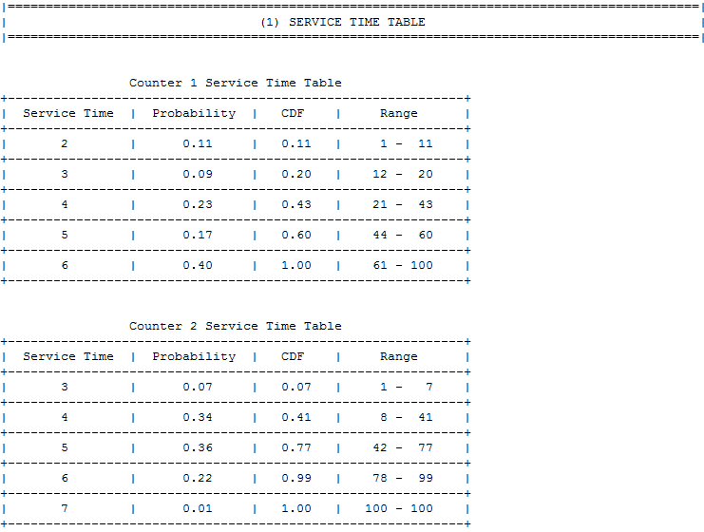

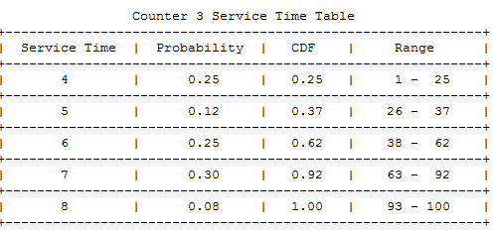

### 2.3.3 INTER-ARRIVAL TIME TABLE

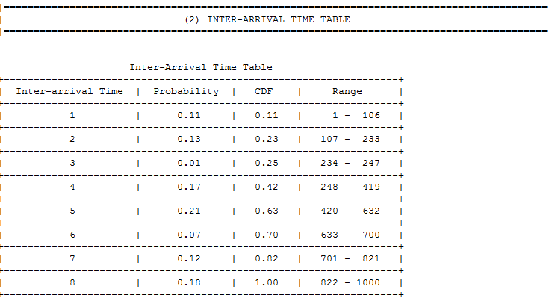

### 2.3.4 ITEM TABLE

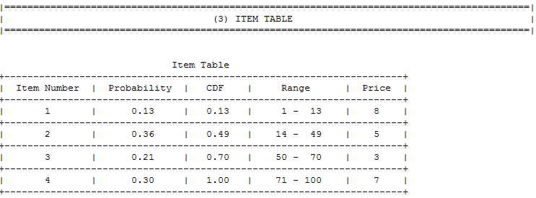

### 2.3.5 SIMULATION TABLE

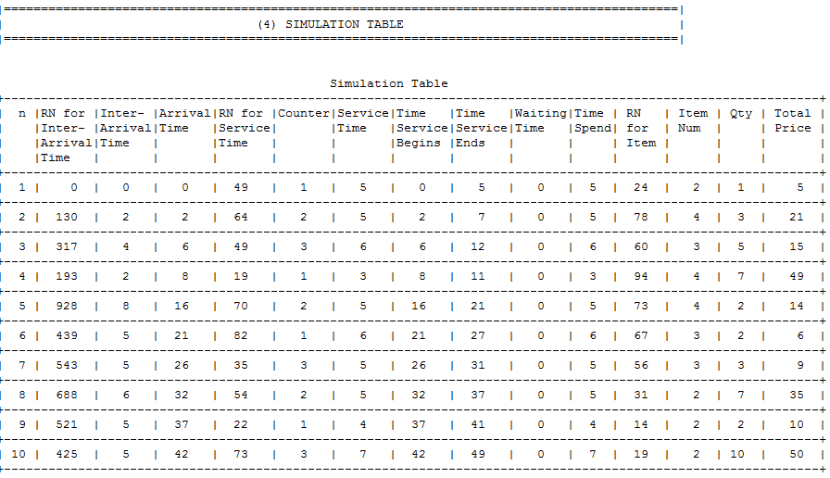

### 2.3.6 COUNTER STATUS

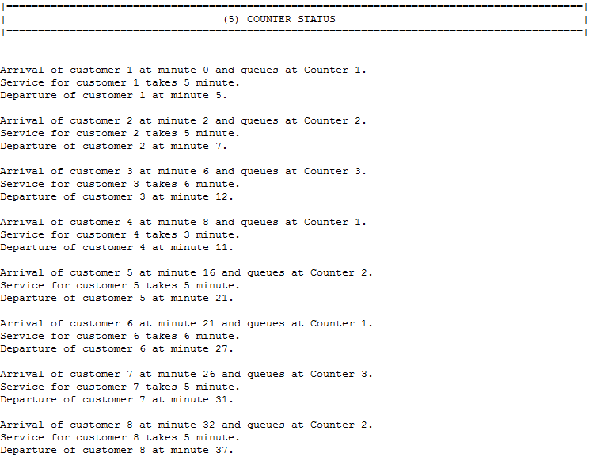

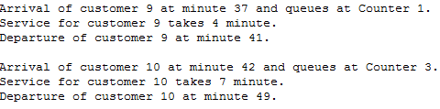

### 2.3.7 EVALUATION OF RESULTS

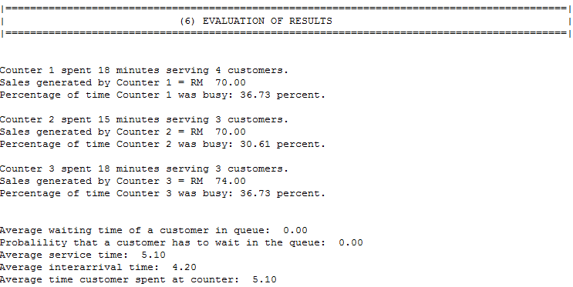

### 2.3.8 CONCLUSIONS

